US HISTORY I KEY IDEAS
Date:
Name:

*UNIT 1: GEOGRAPHY & THE EARLY DEVELOPMENT OF THE U.S.

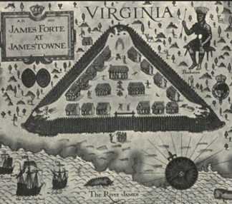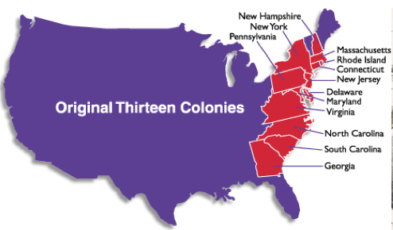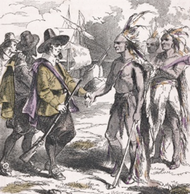

VOCAB DEFINITIONS

1. New England colonies (list) - 6. Early African slavery (3 facts) -

2. Middle colonies (list) - 7. The Great Plains / Rocky Mountains -

- Southern colonies (list) - 8. Southwest / West Coast (describe climates) -

- Plantations (3 facts) - 9. Southeast – Humid Subtropical -

5. Indentured servants (2 facts) - 10. New England/North – Humid Continental -

IMPORTANT CONCEPTS

1. Describe the earliest colonial settlements (Jamestown, Plymouth, and New Netherland)

2. Describe the New England colonies (NH, MA, CT, RI), and 3 facts about their geography:

3. Describe the Southern colonies (MD, VA, NC, SC, GA), and 3 facts about their geography:

4. What geographic feature limited westward expansion? What was the Proclamation Line?

5. Describe 3 facts about the importance of the Mississippi River. What did it become in 1783?
*UNIT 2: MERCANTILISM & COLONIAL ECONOMICS

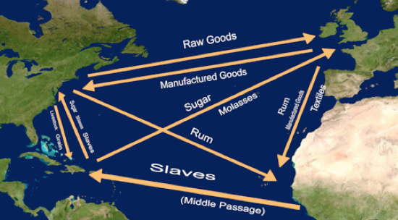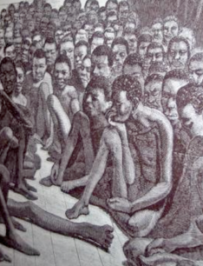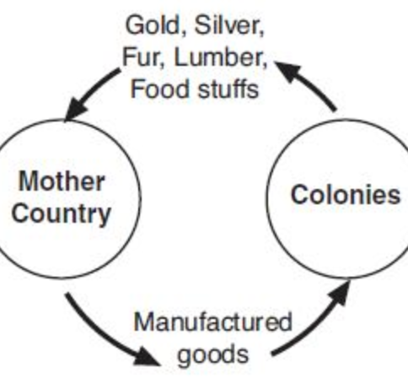

VOCAB DEFINITIONS

1. The Middle Passage - 6. Legislative -

2. Raw materials - 7. House of Lords -

- Export / Import - 8. House of Commons -

- Salutary Neglect - 9. Robert Walpole (1676-1745) -

5. Bicameral - 10. The Quebec Act (1774) -

IMPORTANT CONCEPTS

1. Describe the Triangular Trade across the Atlantic. What human rights violation occurred?

2. Describe 3 facts about Mercantilism and 3 effects it had on European nations and America:

Mercantilism (3 facts) - Effects (3) -

3. Why did Britain follow the policy of Salutary Neglect when dealing with the 13 colonies?

4. What trade restrictions did Britain pass in 1763? List 3 ways the colonists reacted to them:

- Describe 4 ways geography shaped the economic development of the North and South:

New England (2) - The South (2) -
*UNIT 3: LIFE IN THE THIRTEEN COLONIES (1607 – 1775)

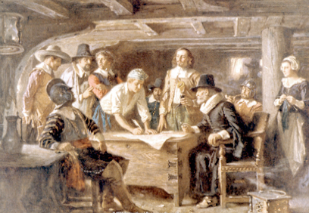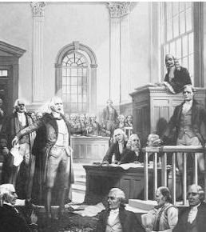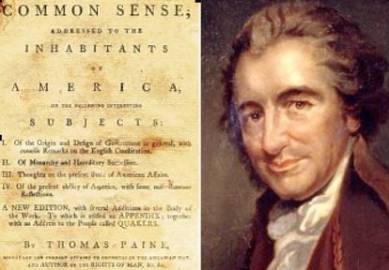

VOCAB DEFINITIONS

1. Self-Government - 6. Why New England town meetings, Mayflower
Compact, House of Burgesses & Fundamental
Orders of Connecticut are all important -

2. The House of Burgesses (1619-1776) - 7. Albany Plan of Union (1754) -

- The Mayflower Compact (1620) - 8. To ‘boycott’ -

- Why the Mayflower Compact matters - 9. “No taxation without representation” -

5. Fundamental Orders of Connecticut (1639) - 10. “Consent of the governed” -

IMPORTANT CONCEPTS

1. What happened in the 1733 trial of John Peter Zenger? Why was this case so important?

2. Describe the French and Indian War. Who fought, when, why, and what were the effects?

3. Britain issued the Proclamation Line of 1763. Describe what it was and list 3 reasons for it:

4. List 3 reasons why relations between Britain and the 13 colonies got worse in the 1760s:

- Thomas Paines’ Common Sense (1776) was a very important pamphlet. List 3 reasons why:

*UNIT 4: THE AMERICAN REVOLUTION (1776 – 1783)

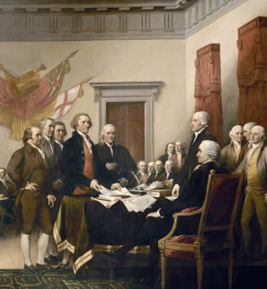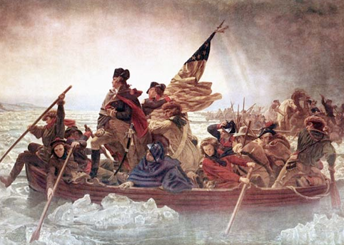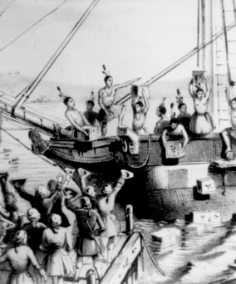

VOCAB DEFINITIONS

1. “No taxation without representation” - 6. Boston Tea Party (Dec. 16th, 1773) -

2. The Sugar Act (1764) - 7. First Continental Congress (1774) -

- The Quartering Act (1765) - 8. Second Continental Congress (1775) -

- Stamp Act (1765) / Townshend Act (1767) - 9. Treaty of Paris (1783) -

5. Boston Massacre (March 5th, 1770) - 10. Key American Revolution battles (list 5) -

IMPORTANT CONCEPTS

1. Describe why Britain and the 13 colonies had a disagreement over the French & Indian War:

Britain’s side - The colonists’ side -

2. Why did the British policy of mercantilism anger the colonists? How did the colonists react?

3. Describe the Coercive Acts (Intolerable Acts) of 1774. How did the colonists respond?

4. Describe 5 facts about Thomas Jefferson’s Declaration of Independence (1776):

5. Why did Britain get defeated, even with a superior army, technology and population size?

UNIT 5: THE ARTICLES OF CONFEDERATION & THE 1780s

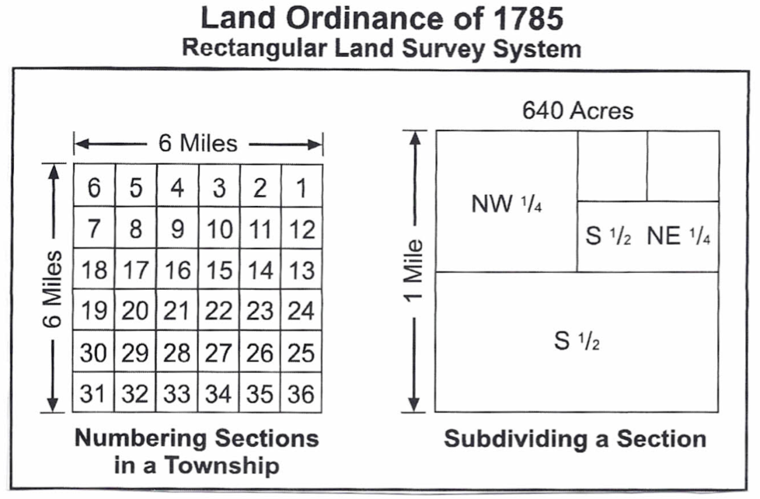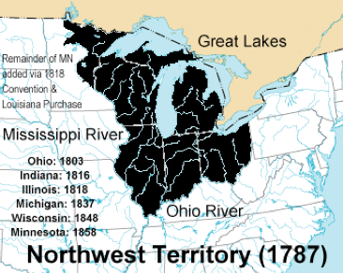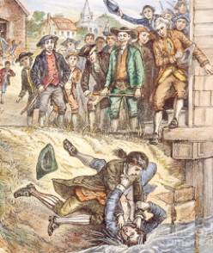

VOCAB DEFINITIONS

1. Articles of Confederation (1781-1789) - 6. Why the Articles was intentionally weak (2) -

2. Ratify - 7. Currency / Legislation -

- Confederation - 8. Land Ordinance of 1785 -

- Sovereign - 9. Facts about the Land Ordinance of 1785 -

5. Tyranny - 10. The Northwest Ordinance of 1787 -

IMPORTANT CONCEPTS

1. Describe what America was like after the Revolution. What task had to be completed?

2. List 4 examples how the Articles of Confederation was a weak government for the new USA:

1. 3.

2. 4.

3. Despite its’ weaknesses, the Articles of Confederation achieved a few things. List 4 below:

1. 3.

2. 4.

4. Why was the Northwest Ordinance of 1787 important? What power was given to Congress?

Important because - Congress’ new power -

- Describe Shay’s Rebellion (1786) and list 3 effects it had on the 13 colonies:

Shay’s Rebellion - Effects (3) -
*UNIT 6: THE CONSTITUTIONAL CONVENTION (1787)

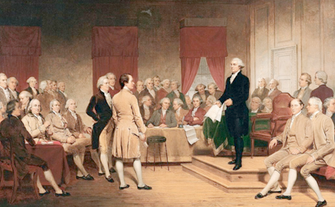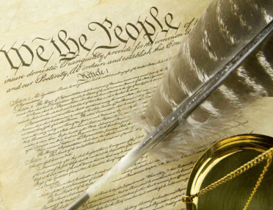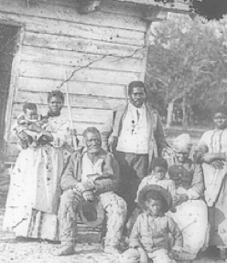

VOCAB DEFINITIONS

1. Delegate - 6. Levy -

2. The Founding Father (list all 6) - 7. The Virginia Plan / Who favored it? -

- “Consent of the governed” - 8. The New Jersey Plan / Who favored it? -

4. Republicanism / Democracy - 9. Bicameral / Unicameral -

5. Weaknesses under the Articles (3) - 10. Why slavery was kept in the Constitution -

IMPORTANT CONCEPTS

1. Describe the Constitutional Convention in 1787. Why was it held, where, how many went?

Where - Why - Attendees -

2. List the people, events, bills, laws and ideas that influenced the authors of the Constitution:

People (3) - Ideas (3) -

Bills/Laws (3) - Events (3) -

3. List 5 changes the new Constitution made to the government compared to the old Articles:

4. Describe the Great Compromise, which settled this issue of representation in Congress:

The Great Compromise (3 facts) -

- Describe the Three-Fifths Compromise. What did the North and South each want and get?

North - South - Three-Fifths Compromise -
*UNIT 7: THE CONSTITUTION (1787) (page 1)

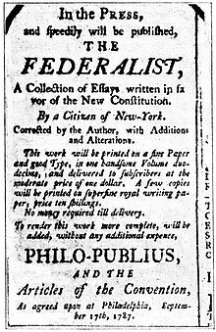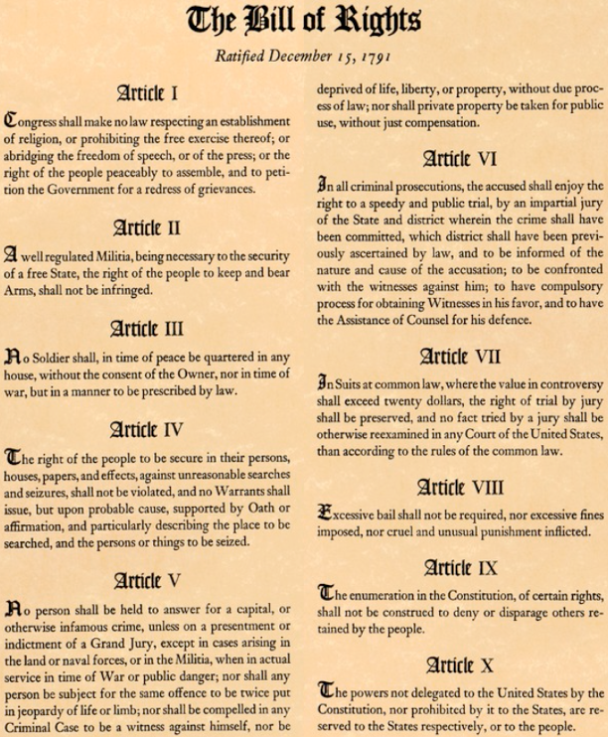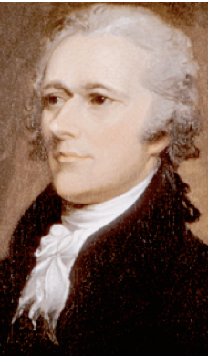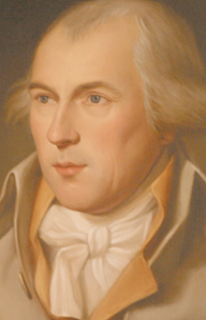

VOCAB DEFINITIONS

1. Federalism - 6. 1st amendment / 2nd amendment -

2. An example of federalism - 7. 3rd amendment / 4th amendment -

- Reason Anti-Federalists were worried - 8. 5th amendment / 6th amendment -

- Civil liberties - 9. 7th amendment / 8th amendment -

5. Trial of John Peter Zenger (2 facts) - 10. 9th amendment / 10th amendment -

IMPORTANT CONCEPTS

1. Describe the dispute between the Federalists and Anti-Federalists. What did each side want?

Federalists - Anti-Federalists -

2. Describe the Federalist Papers (1788). Who wrote them and why?

Federalist Papers - Authors - Why -

3. Why was a Bill of Rights added onto the Constitution? Who was Congress trying to please?

4. How are the Bill of Rights and Declaration of Independence similar? How long is the Bill now?

- Describe the purposes of the 11th and 12th amendments, added onto the Bill after 1791:

11th amendment (1795) - 12th amendment (1804) -
*UNIT 8: THE CONSTITUTION (1787) (page 2)

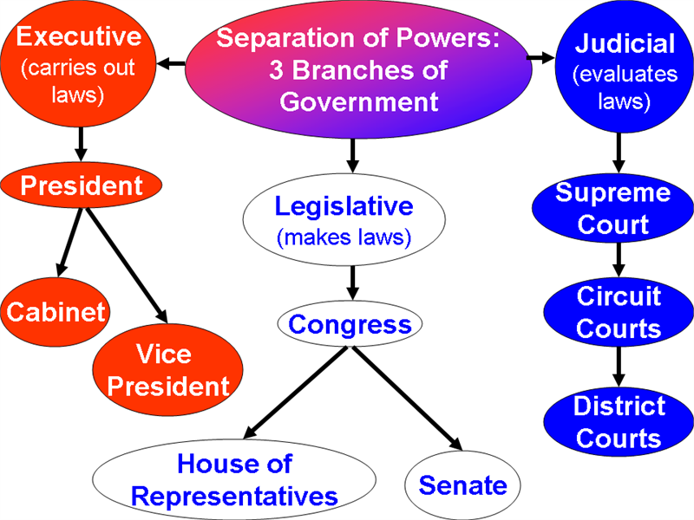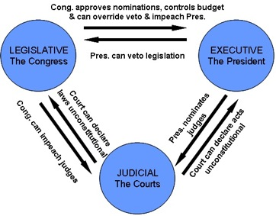

VOCAB DEFINITIONS

1. Popular sovereignty - 6. Separation of powers -

2. Limited government - 7. Veto / Impeach -

- Federalism - 8. Judicial branch (3 facts) -

- Concurrent powers - 9. Checks and balances -

5. Examples of concurrent powers - 10. Void -

IMPORTANT CONCEPTS

1. Describe the Preamble, or introduction, to the Constitution. List 5 things it declares:

2. Describe the delegated powers of the national and state governments:

National (federal) powers (4) - State powers (4) -

3. Describe 5 facts about the legislative (law-making) branch of the federal government:

4. Describe 5 facts about the executive (presidential) branch of the federal government:

5. Give 3 examples of checks and balances, a key principle of the U.S. Constitution:

*UNIT 9: THE CONSTITUTION (1787) (page 3)

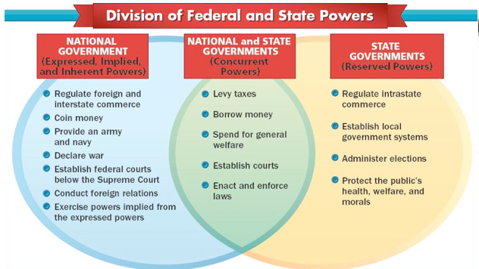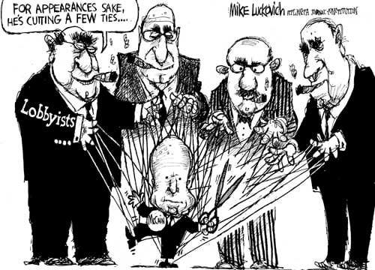

VOCAB DEFINITIONS

1. Flexibility - 6. The Senate (3 facts) -

2. Purpose of the amendment process - 7. The House of Representative (3 facts) -

- The Supremacy Clause - 8. 17th amendment (1913) / Revenue -

- Reserved Powers - 9. Census / Why they’re important to Congress -

5. Examples of Reserved Powers - 10. The 3 roles of the President -

IMPORTANT CONCEPTS

1. Describe the Elastic (Necessary and Proper) Clause and the idea of Implied Powers:

Elastic/Necessary and Proper Clause - Implied Powers -

2. What is the “Unwritten Constitution?” What purpose does it have and list 3 things it led to:

Unwritten Constitution - Purpose - Effects (3) -

3. Describe the special duties of Congress. Why does the House control all revenue bills?

Senate (3) - House of Representative (3) -

4. How do lobbying groups affect Congress? Give an example of one. Why are they dangerous?

5. Describe the Electoral College System created to elect the president. Why is it criticized?

Electoral College System (3 facts) - Why it’s criticized -
*UNIT 10: GEORGE WASHINGTON, THE 1ST PRESIDENT (1789-97)

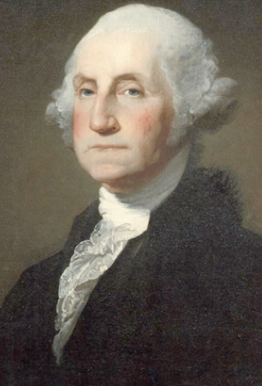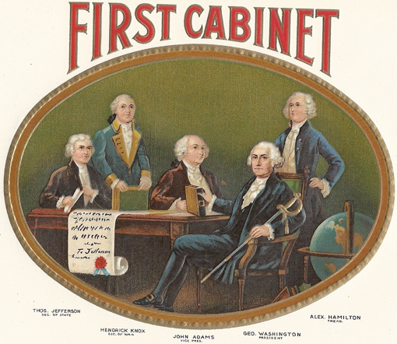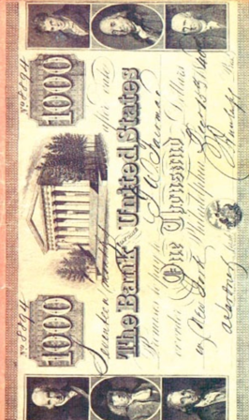

VOCAB DEFINITIONS

1. Precedent - 6. Strict Constructionists (Jefferson/Madison) -

2. Precedents set by Washington - 7. Loose Constructionists (Hamilton) -

- Presidential Cabinet (3 facts) - 8. First Bank of the United States (1791) -

- Sound / Currency - 9. Washington’s Proclamation of Neutrality -

5. Tariff - 10. Washington’s Farewell Address (1796) -

IMPORTANT CONCEPTS

1. Describe 4 reasons why George Washington (1732-1799) is called “the father of his country:”

2. Describe 5 ideas held by Alexander Hamilton (1757-1804) and his Federalist Party:

3. Describe 5 beliefs of Thomas Jefferson (1743-1826) and his Democratic-Republican Party:

4. Describe the Whiskey Rebellion (1791). How did it end, and what did it prove? $

5. Explain why Washington’s Proclamation of Neutrality and Farewell Address were important:

*UNIT 11: LOUISIANA PURCHASE, JEFFERSON & MONROE

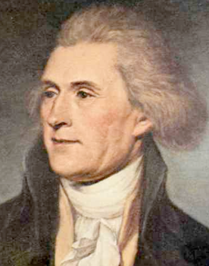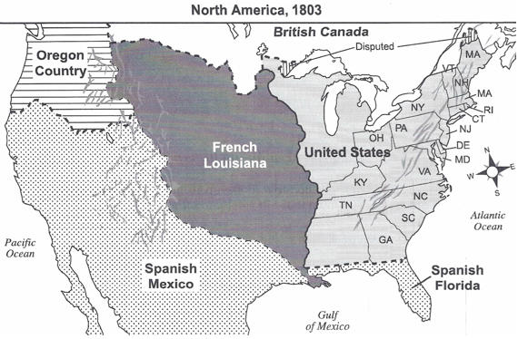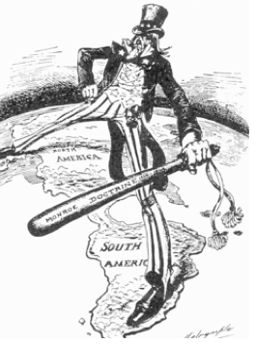

VOCAB DEFINITIONS

1. John Adams (1735-1826) - 6. The Great Plains (2 facts) -

2. Alien and Sedition Acts (1798) - 7. Modern states in the Great Plains (8) -

- Thomas Jefferson (1743-1826) - 8. The Embargo Act (1807) / Impressment -

- The Western frontier (2 facts) - 9. Reasons the Embargo Act failed (3) -

5. Why the Mississippi River mattered - 10. The War of 1812 (4 facts) -

IMPORTANT CONCEPTS

1. Describe the historical circumstance (background info.) of the Louisiana Purchase (1803):

2. Describe 5 results (effects) of the Purchase, one of Jefferson’s greatest accomplishments:

3. Describe 3 facts how the Purchase posed a dilemma for Jefferson. How did he finally decide?

Why it was a dilemma - How Jefferson decided -

4. Describe 3 facts about President James Monroe’s (1758-1831) Monroe Doctrine (1823):

5. Why did the US issue the Monroe Doctrine? What past presidential policies was it similar to?

Why it was issued - Similar to (2) -
*UNIT 12: EARLY SUPREME COURT DECISIONS

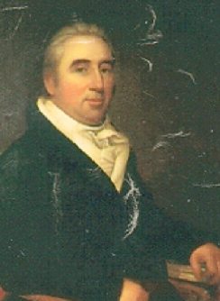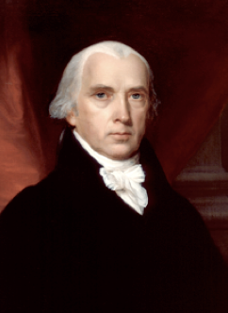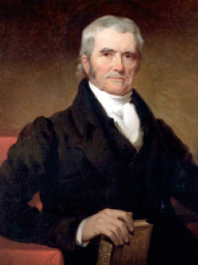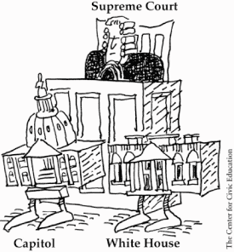

VOCAB DEFINITIONS

1. Jurisdiction - 6. District of Colombia -

2. Maritime - 7. Judicial review -

- Supreme Court justice - 8. Unconstitutional -

- Original/Appellate jurisdiction - 9. McCulloch v. Maryland (1819) (2 facts) -

5. Judiciary Act of 1789 - 10. Gibbons v. Ogden (1824) (2 facts) -

IMPORTANT CONCEPTS

1. Describe the judicial (legal) branch. What types of cases are heard in federal courts?

Judicial Branch (3 facts) -

Cases heard in federal courts (5) -

2. Describe 5 facts about the Supreme Court, the highest court in the nation:

3. Describe 3 facts about the 4th Chief Justice, John Marshall, who served from 1801-1835:

4. Describe the Supreme Court case Marbury v. Madison (1803). What was the decision (result)?

Marbury v. Madison (1803) - The Decision -

- Describe 3 effects of the power of judicial review, which came out of Marbury v. Madison:
*UNIT 13: ANDREW JACKSON, HUMAN RIGHTS & IMMIGRATION

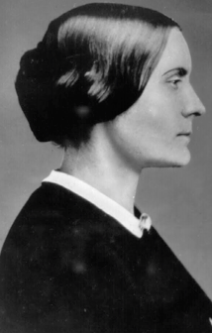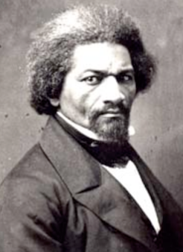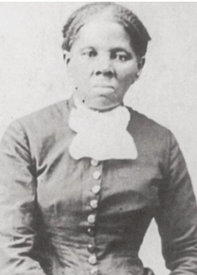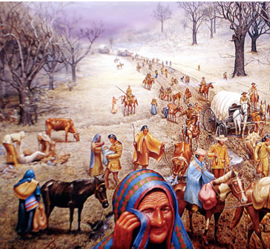

VOCAB DEFINITIONS

1. “Jacksonian Democracy” - 6. Why abolitionists opposed western states -

2. Why voter participation increased - 7. Uncle Tom’s Cabin (1852) (3 facts) -

- Spoils System / What Jackson claimed - 8. Causes of the Industrial Revolution (3) -

- Second Two-Party System (2 facts) - 9. Why few restrictions were put on immigration -

5. Worcester v. Georgia (1832) - 10. Economic scarcity -

IMPORTANT CONCEPTS

1. Describe President Jackson’s policy towards Native Americans. What was the Trail of Tears?

Jackson’s policy - Trail of Tears (1838) (3 facts) -

2. Describe the birth of the Women’s Rights Movement at the Seneca Falls Convention (1848):

Goal - Leaders (3) - Declaration of Sentiments -

3. Describe the Abolitionist (Anti-slavery) Movement. The goal, leaders, Underground Railroad

Goal - Underground Railroad - Leaders (4) -

4. Describe the immigration from Europe after the US industrialized. Who came, why, when…

Who came - Why - When - Why Ireland? -

- Explain 3 ways immigrants faced discrimination. What did native-born Americans fear?

Immigrant discrimination (3) - What Americans feared -
*UNIT 14: MANIFEST DESTINY

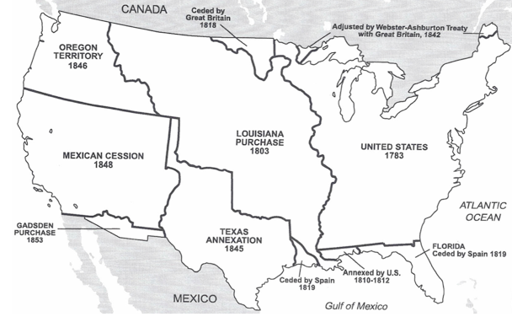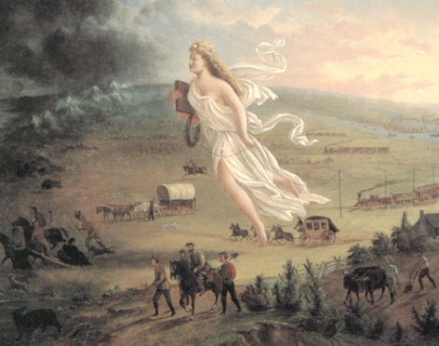

VOCAB DEFINITIONS

1. Manifest Destiny - 6. To ‘cede’ -

2. What Manifest Destiny justified - 7. Florida (1819) -

- Manifest Destiny presidents - 8. The Gadsden Purchase (1853) -

- “Fifty-Four Forty or Fight!” - 9. The ‘Forty-Niners’ -

5. Treaty of Guadalupe Hidalgo (1848) - 10. Goal of the Homestead/Pacific Railway Act -

IMPORTANT CONCEPTS

1. Describe the Erie Canal (1825) and how canals and railroads improved commerce (business):

Erie Canal (1825) - Effects of canals & railroads -

2. Describe the conflict between the USA & Britain over the Oregon territory. What happened?

What the USA wanted - What Britain wanted - Polk’s compromise -

3. Describe the conflict between the USA & Mexico over Texas. What led to the problem?

Background - What the USA wanted - What Mexico wanted -

4. Describe 3 effects of the Mexican-American War (1846-1848). List 5 states that were gained:

Effects (3) - US states gained (5) -

5. Describe the Homestead and Pacific Railway Acts. How did railroad companies profit?

Homestead Act (1862) - Pacific Railway Act (1862) -
*UNIT 15: THE CIVIL WAR (1861-1865)

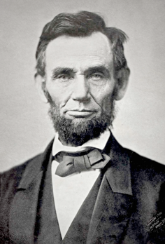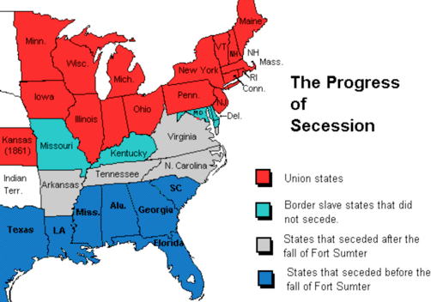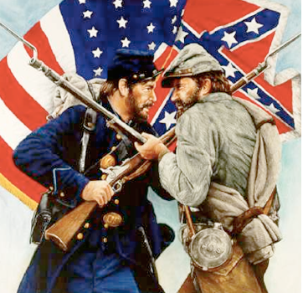

VOCAB DEFINITIONS

1. American Civil War (1861-1865) - 6. Fugitive Slave Act (1850) -

2. Sectionalism - 7. Where slaves now went / Nullification -

- Popular sovereignty - 8. To ‘secede’ -

- The Missouri Compromise (1820) - 9. “Bleeding Kansas’ -

5. The Compromise of 1850 - 10. The Republican Party (1854) -

IMPORTANT CONCEPTS

1. Describe differences between the North and South’s economies at the dawn of the Civil War:

South’s economy/effects - North’s economy/effects -

2. Describe the Supreme Court case Dred Scott v. Sanford (1857). What effects did it have?

3. Describe the Kansas-Nebraska Act (1854) & John Brown (1859). What effect did they have?

Kansas-Nebraska Act - John Brown - Effect -

4. Describe the path to the Civil War (1861-1865) after President Lincoln’s election in 1860:

Lincoln’s goal after election - The South’s response -

- Describe 4 reasons the North (the Union) won. Why did the North’s economy grow?

*UNIT 16: RECONSTRUCTION & THE JIM CROW SOUTH

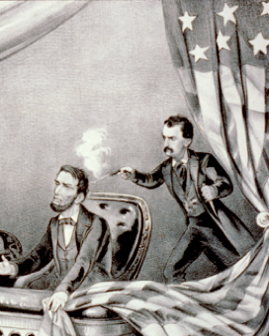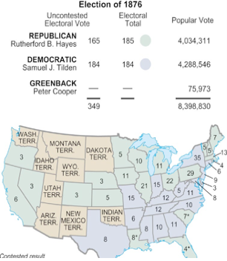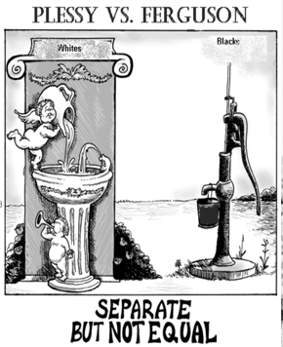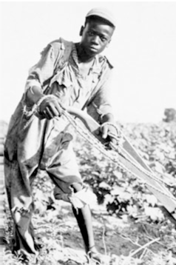

VOCAB DEFINITIONS

1. Effect of the Civil War - 6. 15th amendment (1870) -

2. Impeachment /Johnson’s fate - 7. The Solid South -

- The Freedman’s Bureau - 8. Jim Crow Laws / Sharecropping -

- 13th amendment (1865) - 9. Plessy v. Ferguson (1896) -

5. 14th amendment (1868) - 10. Effect of Plessy v. Ferguson -

IMPORTANT CONCEPTS

1. Describe Reconstruction (1865-1877). What was Lincoln’s goal? Why did he want this?

Reconstruction - Lincoln’s goal - Why? -

2. Describe the conflict between the Radical Republicans in Congress and President Johnson:

Radical Republicans - President Johnson -

3. Describe 3 positive and 3 negative changes to the South under Reconstruction:

Positive effects (3) - Negative effects (3) -

4. Why was the election of 1876 a controversy? Explain the terms of the Compromise of 1877:

Election of 1876 - Compromise of 1877 -

5. Give 10 examples of discrimination faced by African-Americans after Reconstruction:

*UNIT 17: THE RISE OF BIG BUSINESS IN THE LATE 1800s

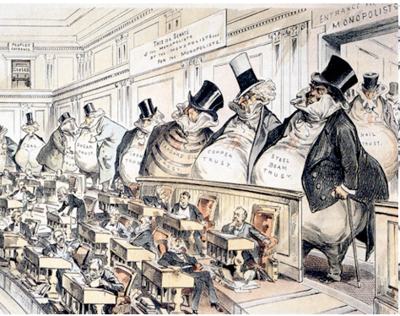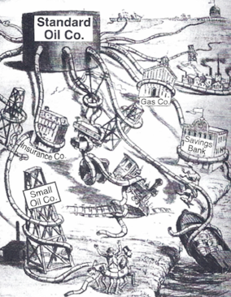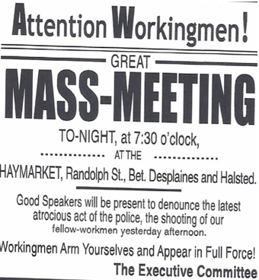

VOCAB DEFINITIONS

1. The Assembly Line - 6. Wabash, St. Louis Pacific Railroad v. Illinois (1886) /
United States v. E.C. Knight Co. (1895) -

2. Tariffs - 7. Blacklists / Yellow-Dog Contracts -

- Why businesses wanted tariffs - 8. American Federation of Labor (AFL) -

- The Standard Oil Trust - 9. Why strikes failed (2 reasons) -

5. Monopoly/ Efficient / Vast - 10. Triangle Shirtwaist Company Fire (1911) -

IMPORTANT CONCEPTS

1. Describe the industrialization and economic growth of the USA in the late 1800s:

Business leaders (3) - Inventors (5) - Effect of railroads -

2. How did laissez-faire Capitalism lead to economic growth? Why were pools and trusts used?

Laissez-faire Capitalism - Pools and trusts -

3. How did businessmen use Social Darwinism to their advantage? What did it justify to them?

4. Why were big business leaders called ‘Robber Barons?’ List 3 laws passed to stop them:

- Describe the growth of American unions, which fought for workers’ safety and wages:

“Bread and butter” Unionism - Leaders (3) - Strikes (2) -
*UNIT 18: ‘NEW IMMIGRATION’ & THE POPULIST MOVEMENT

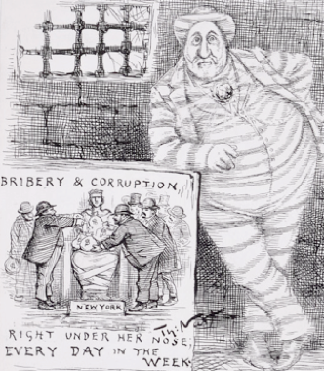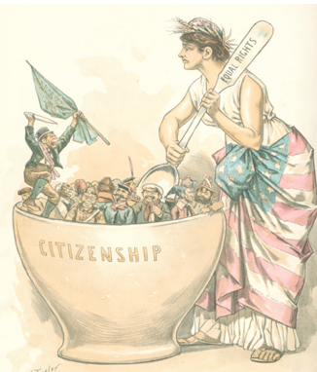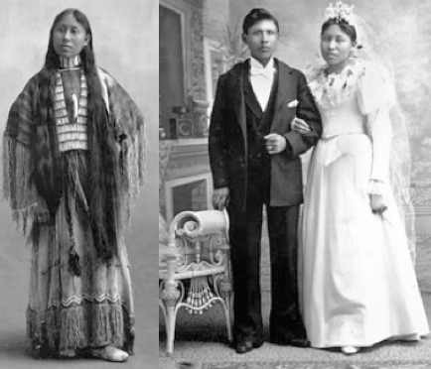

VOCAB DEFINITIONS

1. Urbanization - 6. Nativism / “America is for Americans” -

2. Effects of Industrialization (3) - 7. Mechanization / Effect on Agriculture -

- Tenements/ Slums - 8. Graduated national income tax -

- “The Gilded Age” - 9. Election of 1900 (sides, winner, why) -

5. ‘Melting Pot’ - 10. Why Populist ideas mattered -

IMPORTANT CONCEPTS

1. Describe political machines. What were they similar to? Describe 3 facts about Boss Tweed:

Political Machines (3 facts) - Boss Tweed (3 facts) -

2. Describe the period of ‘new immigration’ (1890s-1920s). Why were so many allowed in?

New Immigration (3 facts) - Why the government placed few restrictions -

3. Describe 5 examples of nativism in the USA. Why did labor unions oppose immigration?

Examples of nativism (5) - Why unions opposed immigration -

4. List 5 reasons the Plains Indians declined in the late 1800s. Why was the Dawes Act bad?

Plains Indians decline (5) - Dawes Act (1887) -

5. List 5 demands of the Granger and Populist Movements (late 1800s). What did they want?
*UNIT 19: THE PROGRESSIVE ERA (1890s – 1920s)

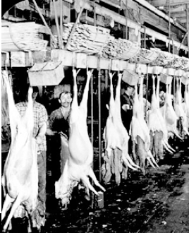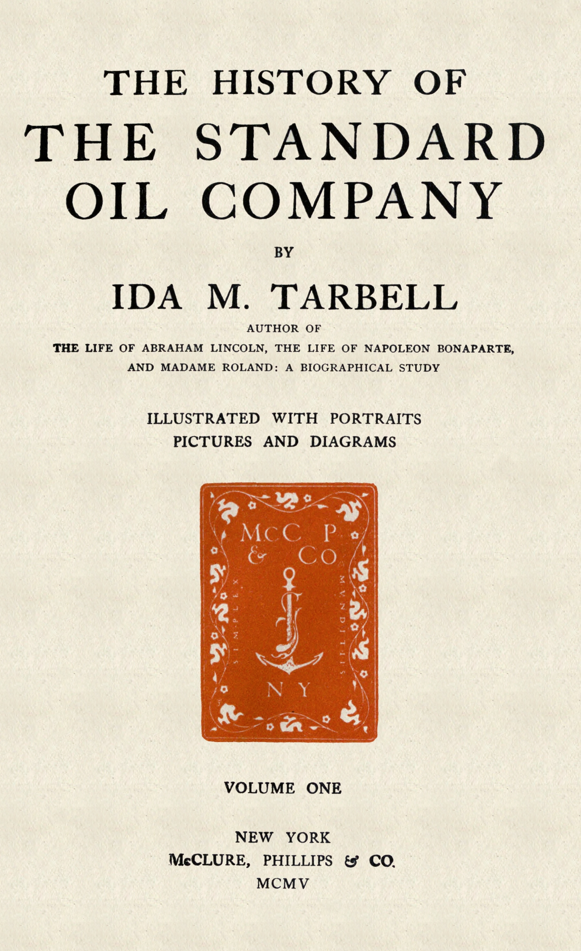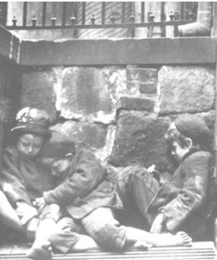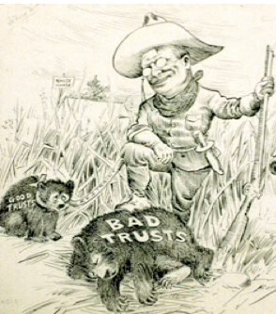

VOCAB DEFINITIONS

1. 16th amendment (1913) - 6. Dorothea Dix (1802-1867) -

2. Why the Progressive Movement formed - 7. Margaret Sanger (1879-1966) -

- Direct Primary / Graduated income tax - 8. How the Other Half Lives / Hull House -

- 17th amendment (1913) - 9. Teddy Roosevelt’s “Square Deal” (3 facts) -

5. Pure Food and Drug Act (1906) / 10. Why Roosevelt was a ‘trustbuster’ -
Meat Inspection Act (1906) -

IMPORTANT CONCEPTS

1. List 5 political reforms of the Progressive Era. How was it similar to the Populist Movement?

Progressive Era reforms (5) - Similarities to Populist Party (2) -

2. What institutions were created to regulate big business? What is a ‘watchdog’ group?

Business regulators (3) - A ‘watchdog’ group -

3. Describe 5 facts about the muckrakers. What types of people were they? What did they do?

4. List the names and effects of the two novels by muckrakers Upton Sinclair and Ida Tarbell:

Upton Sinclair (1878-1968) - Ida Tarbell (1875-1944) -

- Describe 3 facts each about two other famous muckrackers, Jacob Riis and Jane Addams:

Jacob Riis (1849-1914) - Jane Addams (1860-1935) -
*UNIT 20: SUFFRAGE, CIVIL RIGHTS & THE FEDERAL RESERVE

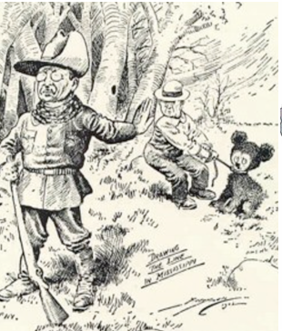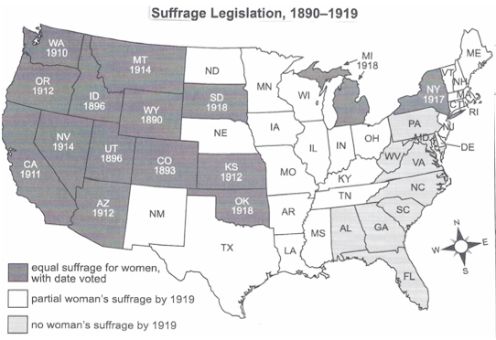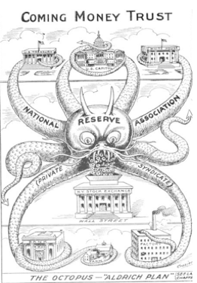

VOCAB DEFINITIONS
‹
1. Carrie Chapman Catt (1859-1947) - 6. W.E.B. Du Bois (1868-1963) -

2. Suffrage / 19th amendment (1920) - 7. Booker T. Washington (1856-1915) -

- Gifford Pinochet (1865-1946) / 8. Tuskegee Institute (1881) -
John Muir (1838-1914) -

- Prohibition /Bootlegging / Repeal - 9. What the Federal Reserve is similar to -

5. 18th amendment (1919) / 10. Sound / Currency -
21st amendment (1933) –

IMPORTANT CONCEPTS

1. What state granted full suffrage first? What did women do and where’d they work to earn it?

1st states with full suffrage (4) - What women did/worked in (4) -

2. Describe the Conservation movement. How was Theodore Roosevelt (1858-1919) a leader?

Conservation Movement - Theodore Roosevelt (3 facts) -

3. Describe the growth of the Temperance (prohibition of alcohol) movement. Why did it fail?

Temperance Movement - Why it failed (4 reasons) -

4. List 4 things the African-American civil rights movement opposed. What was the N.A.A.C.P.?

- Describe what the Federal Reserve System (1913) is. Who made it, and list 5 things it does:

Federal Reserve System - What it does (5) -

